# Project Document Information

|  |  |
| --- | --- |
| **Project name:** | Trekking App |
| **Date:** | 08/03/21 |
| **Authors:** | Software Project Team 9  118410722 Adam Evans  116451016 Eoin O’Connell  118332823 Oliwia Kobos  118359221 Pádraig Ó Cróinín  118476662 Adrian Lamug |
| **Product Owner:** | Jason Quinlan |
| **Version:** | v0.6 |
| **Colour Code:** | Newly added updates  Updates added from the peer review |

# Definition

|  |  |
| --- | --- |
| **Main Goal:** | To provide an easy to use mobile application for finding walking paths. |
| **Desired Outcomes:** | Easy to find trails near your location with the ability to customise the paths based on user needs. |
| **Constraints and Assumptions:** | App will be available to mobile devices that have access to a working internet connection  User will confirm access to GPS location  Google Maps limitations to available routes  Current Google Maps API plan provides plenty of credits to use however when scaling the application, the costs scale as well. |
| **Interfaces:** | Google Maps, trails API |

# Key Stakeholders

|  |  |
| --- | --- |
| **Major Stakeholder** | **Notes** |
| **Jason Quinlan** | PRODUCT OWNER |
| **Adam Evans** | APPLICATION DEVELOPER   * Enabling the app to create push notifications * Creating a notifications tab |
| **Eoin O’Connell** | APPLICATION DEVELOPER   * Adding Maps fragment to app * Updating Project Brief |
| **Oliwia Kobos** | UI/UX DESIGN   * Designing the app’s UI * Implementing the UI design * Managing the Google Cloud project APIs * Creating product documentation |
| **Pádraig Ó Cróinín** | SOFTWARE TESTER   * Integrating Maps API with app * Working with Trails API * Managing given trails within the app |
| **Adrian Lamug** | SYSTEMS ARCHITECT   * Implementing the UI design * Setting up a database for the app * Implementing navigation between app fragments * Configuring app permissions * Retrieving and using the user’s location |

# Project Objectives

|  |  |  |
| --- | --- | --- |
|  | **Target** | **Tolerance** |
| **Scope** | Ideally hitting our MoSCoW targets | Hitting just the must targets |
| **Time** | 7 weeks | 8 weeks |
| **Cost** | Hopefully no costs will arise |  |
| **Quality** | A polished, working product |  |
| **Risks** | Using up Google Maps credits |  |
| **Benefits** |  |  |

# 

# Outline Business Case

Since the introduction of lockdown measures due to Covid-19 many people are finding themselves spending more time than normal at home. Therefore, there is a bigger interest in making up for lost movement through exercising at home. Our application identifies the possible market of mobile users who are stuck in the same monotonous routine that makes walking seem more burdensome than necessary.

The Trekking App intends to use the readily available Google Maps API to create and track customisable routes, allowing users to have a new experience every time they venture outside. Users can avail of features such as filters that allow them to set the maximum or minimum distance of a route, adhering to the exercise guidelines established. The application can include scenery or places of interest during the walk, tap into local weather news to predict path conditions, track user stats, and more.

Unlike other applications on the market, the Trekking App’s main benefit is in combining both rural and urban landscapes, minimising the need for major travel and creating something available to all without limiting features based on someone’s locations.

# Product Description

Our project is a reaction to the health crisis being caused by the covid-19 pandemic. In order to try and promote exercise and help people get out of their homes to destress we plan on creating a mobile app that will pick out walking paths for people that abide by the Covid-19 guidelines at the time.

This application will serve as a recommendation guide for the user to make their walk more interesting, not as a navigation system to get from place A to place B. Therefore it is up to the user’s discretion on how closely they choose to follow the path.

**Must-Have Features**

* Trail suggestions should not be over 5km away from the user’s home.
  + Displays 5km perimeter around user’s location ✓
  + Trails highlighted differently depending on if they are in the user’s 5k or not ✓
* Notifications (Covid-19 updates, weather warnings)
* GPS tracking during the course of the route, and upon completion of trail.
  + Track user’s location and can compare with coordinates along trail ✓
* Favourites tab containing saved trails.

**Should-Have Features**

* The app should have a feature for the user to filter route types such as “Scenic Routes”.
* Option to filter by rating and popularity and length of the trail.
* Track user stats such as steps taken, distance travelled, average pace, etc.
  + User steps are successfully tracked ✓
  + Database setup within app to track user stats on particular trails ✓
* User performance report at the end of each week.

**Could-Have Features**

* Path creator feature which would allow the user to create the trails manually
  + User location taken at intervals and used to draw a trail ✓
  + Database setup within app for trail storage ✓
* Path sharing feature
* Option to share performance on social media
* “Marathon Mode” could allow a user to build up longer walking or running distances.
* Keep track of trail traffic.

**Won’t-Have Features**

* Offline support. We shall have to make assumptions that any user with access to our mobile application will also have access to Wi-Fi and mobile data.
* Caching the trails before the user goes on walks.

**Project Architecture:**

The interfaces that the application will be interacting with are the Trails API as well as the Google Maps API. Using a user’s location, Google Maps should filter trails from the Trails API, and return to the user the appropriate trails.

The initial architecture plan (shown in Figure 1) has changed. In order to comply with GDPR and to ensure confidentiality, the user’s location will not leave their device. All trails will be stored locally on the user’s device. The work will then be done locally to calculate, using the user’s location, which routes are appropriate. These routes will then be visualised using Google Maps. The user’s location will not leave their device. These architectural changes are reflected in Figure 2. If this changes in future than other concerns will arise regarding secure storage of users data.

Figure 4 displays the overall architecture of the project. This diagram was agreed upon after each team member created architecture diagrams based on their own perspective. Figure 4 is the agreed result of these diagrams combined.

**Sequence Diagram**

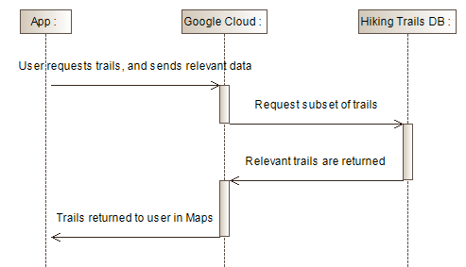

*Figure 1: Initial Sequence Diagram idea. User’s location would be sent to Google Cloud which would fetch relevant trails.*

**New Sequence Diagram**

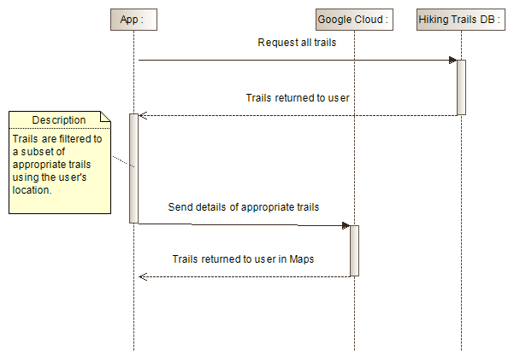

*Figure 2: Revised Sequence Diagram idea. User’s location does not leave their device, but instead all trails are kept locally and filtered locally. This change was made to avoid GDPR issues*

**USER STORIES**

*Figure 3: Updated User Stories for the project.*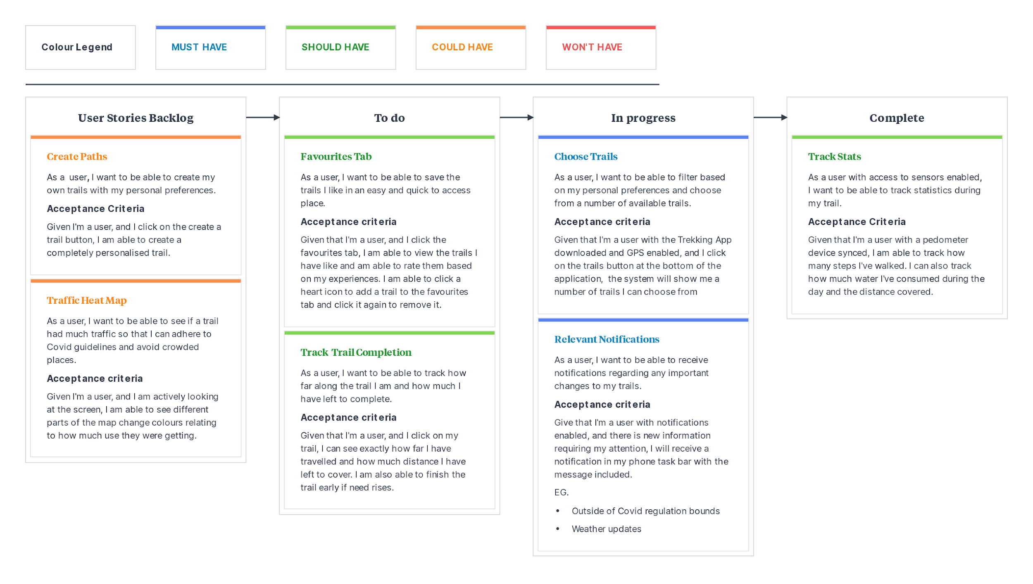

**Overview Diagram:**

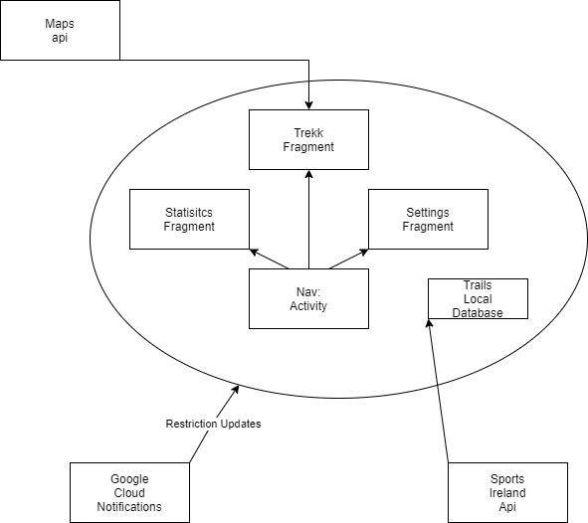

*Figure 4: Overall architecture diagram of the project, showing different components interacting*

# 

# 

# Gantt Chart:

**Short-term Gantt:**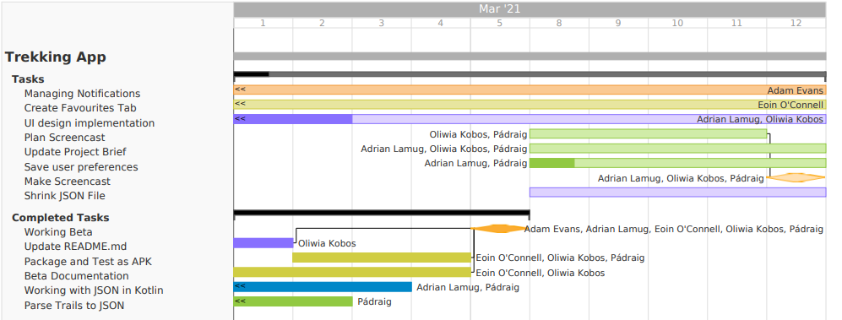

**Forecasting Chart:**